washingtonalpineclub.org – Author Guide

“Author” is a Wordpress role enabling one to create posts and calendar updates. A good discussion of Wordpress rolls can be found at <http://codex.wordpress.org/Roles_and_Capabilities>.

(Note: The Author role does not allow one to create and update pages.)

1. Login to the washingtonalpineclub.org website. To get to the admin menu, add “wp-admin” to the end of the URL in the browser address box, as seen below.

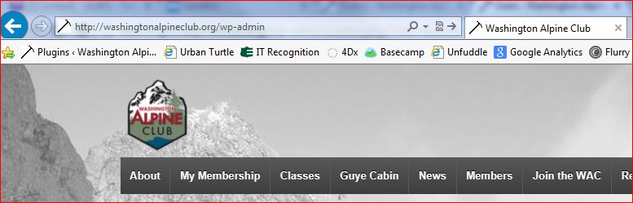

1. You’ll get to the admin panel. From here you can create new posts and calendar entries (or edit existing ones. Try clicking on the items indicated below.

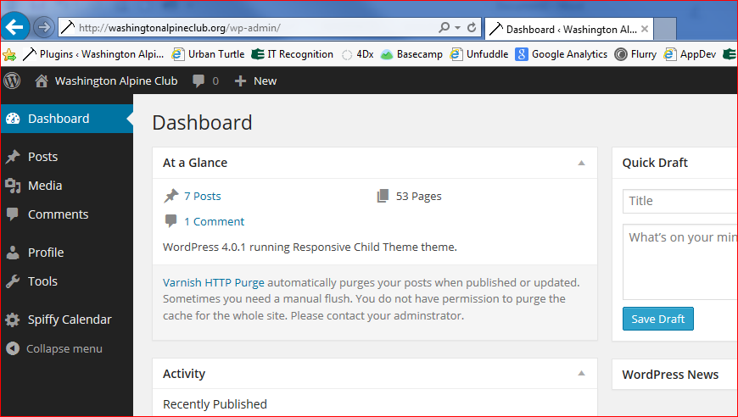

1. Here I’ve selected to create a new post. Give it a title, edit the content in the content box below the title and add media if you wish (just use reasonably sized image files – big ones just take longer to download). You don’t want to change the restrictions on the right-hand side of the page, but you can categorize or add tags to the posts. Press “Publish” to publish the post. The published post will show up under “News” on the menu, and on sidebars throughout the site.

